[**SETTING UP APPLICATION ENVIRONMENT**](https://careereducation.smartinternz.com/Student/guided_project_workspace/38367#collapse1)

# Create IBM Cloud Account

|  |
| --- |
| Date: 2nd Nov 2022 |
| Team ID: PNT2022TMID53527 |
| Project Name: Smart Fashion Recommender Application |

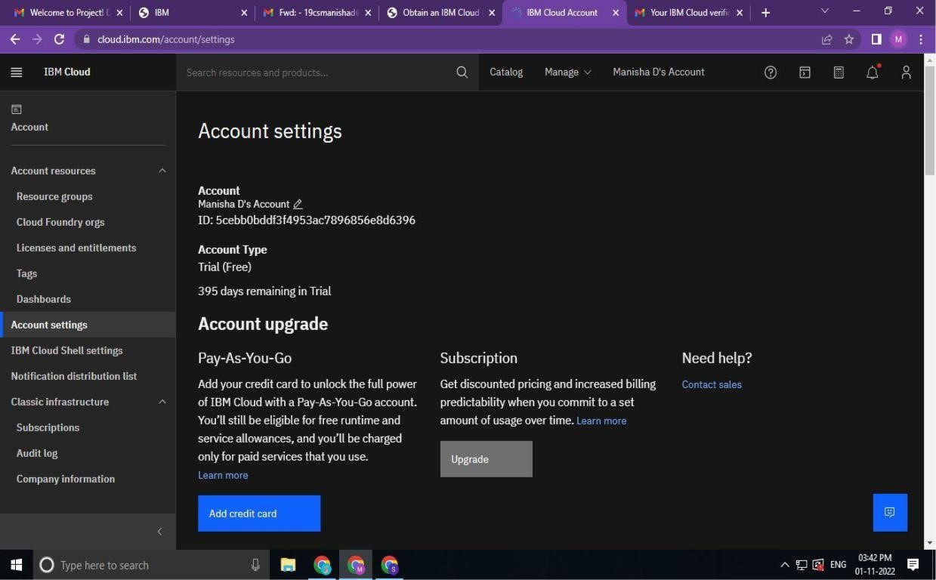

IBM Cloud Account has been created.